**CS 1632 - DELIVERABLE 3: Automated System Testing of a Web Application**

Evan Kiebler – ekiebler1

Kat Debick – katherinedebick

Github Link: <https://github.com/ekiebler1/D3>

Introduction:

This project was a nice change of pace from D2it was a lot more straightforward and too friendly to work on than D2. The program itself was relatively straight forward; the 3 tasks the site is supposed to do are all things we’ve coded at least once before so the logic was easy to convert to ruby. As for the erb/Sinatra side of it, coding that was similar to the most recent exercise we did in class except with 3 functions instead of 2. Modifying that was also pretty simple.

Katatlon is one the most user friendly tools for coding that we’ve seen in a long time. The ability to hit record, do the test yourself, and then have it convert it to HTML is super easy and convenient to use. It made writing the tests for each quick and made running through all of them after as new features were added a breeze.

Traceability Matrix:

|  |  |
| --- | --- |
| Requirement: | Tests: |
| 1. The system shall run on localhost, port 4567, and thus accessible via "[http://localhost:4567](http://localhost:4567/)", after running the command ruby number.rb. |  |
| 1. Upon accessing root ("/", i.e., [http://localhost:4567](http://localhost:4567/)), the system shall display a page with three textboxes and three submit buttons, arranged together and each labeled. |  |
| 1. The first set shall be labeled "Fibonacci" (with the button labeled "Calculate"), the second "Factorial" (with the button labeled "Calculate"), and the third "Say hello" (with the button labeled "Hi"). |  |
| 1. If the Calculate button in the Fibonacci section is pressed, the value in the Fibonacci textbox will be interpreted as an integer and a new page will be shown which displays "Fibonacci(n) = m" where n is the input integer and m is the nth value of the Fibonacci sequence. | Fibo Test 1  Fibo Test 5 |
| 1. If the Calculate button in the Factorial section is pressed, the value in the Factorial textbox will be interpreted as an integer and a new page will be shown which displays "Factorial(n) = m" where n is the input integer and m is equal to n! (n factorial) | Fact Test 1  Fact Test 5 |
| 1. If the "Hi" button in the "Say hello" section is pressed, the value in the "Say hello" textbox will be interpreted as a string and a new page will be shown which displays "Hello, X!" where X is the capitalized version of the input string (e.g., "bob" becomes "BOB", "jAnE" becomes "JANE", "XIAOTING" becomes "XIAOTING". | Hi Test All Lower  Hi Test All Caps  Hi Test Differing Caps |
| 1. Any invalid data entered in the Fibonacci or Factorial textbox (e.g. blank text, "poodle", etc.) shall be considered to be the value 1. | Fibo Test String  Fibo Test Double  Fibo Test Nil  Fact Test String  Fact Test Double  Fact Test Nil |
| 1. Values entered in textboxes other than the one for which the button is pressed shall be ignored. For example, if the user enters "7" in the Fibonacci textbox, and enters "Bob" in the "Say hello" textbox, then presses the Fibonacci | Fibo Test Other Inputs  Fact Test Other Inputs  Hi Test Other Inputs |
| 1. Every result page (as enumerated in requirements 3, 4, and 5, above) shall contain a link labeled "Back to main" which will take the user to the main page. | Fibo Test Back To Main  Fact Test Back To Main  Hi Test Back To Main |
| 1. If a user goes to a URL other than root (e.g., "<http://localhost:4567/hotdog>") the system shall display a page stating, in an h1 tag, "ERROR", and in regular text, "That page does not exist", along with a 404 error code | Other Page Test |

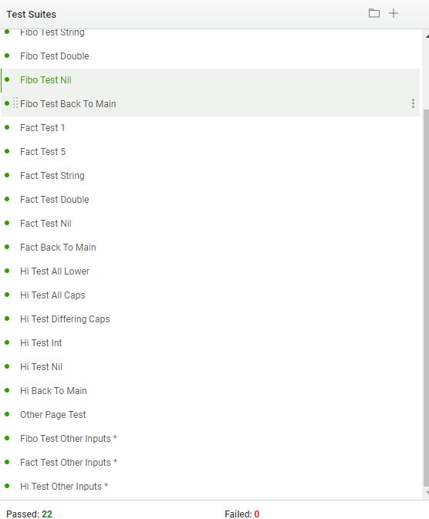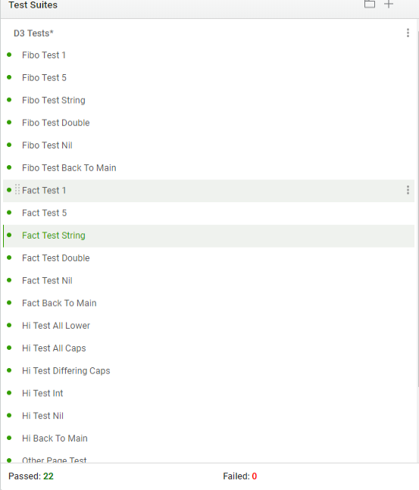Test Proof: